**Bellringer:**  Endosymbiosis and Compartmentalization

AP Biology

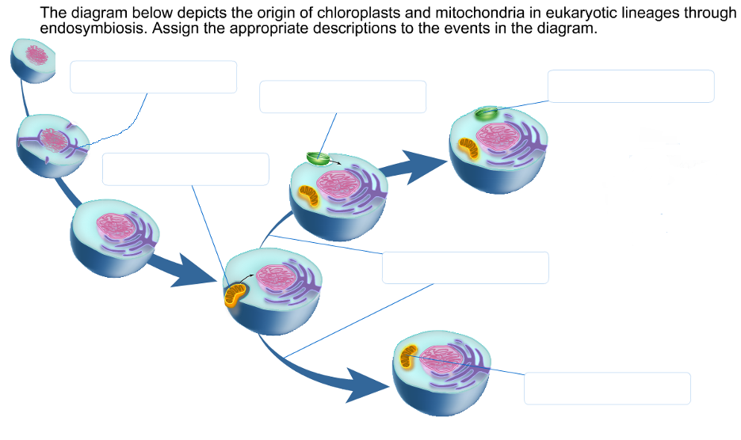

| Ancestral heterotrophic eukaryotes develop | Heterotrophs diverge away from autotrophs | Infolding of plasma membrane occurs | Ancestral autotrophic eukaryotes develop | Engulfing of aerobic prokaryote (bacterial cell) | Engulfing of photosynthetic prokaryote (bacterial cell) |
| --- | --- | --- | --- | --- | --- |

**Explain** how each of the images below provides evidence that supports the claim that mitochondria likely evolved from primitive bacteria.

|  |  |
| --- | --- |
| **Explanation:** | **Explanation:** |